B39SB Time and Frequency Signal Analysis – Tutorial 4

P1. Given that and , determine the Laplace transforms of the following functions

P2. Use the Laplace transform to solve the follwoing differential equation
.

P3. The circuit shown below is at steady state before the switch closes at time . Determine the inductor current after the switch is closed.

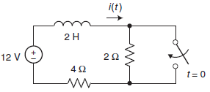

P4. Let be the one-sided Laplace transform of . Determine and .

